*Today’s the day the Teddy Bear’s have their Picnic!*

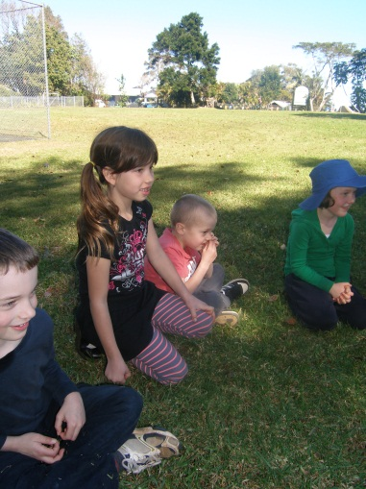

**Goonengerry Teddy Bear’s Picnic**

C:\Users\agumbrell\AppData\Local\Microsoft\Windows\Temporary Internet Files\Content.IE5\HG2ZGFY2\MC900232136[1].wmf

On Friday, 24 August 2012

9.30am til 12.30pm

We will provide a delicious, nutritious picnic lunch including

Nori Rolls, Corn Cobbs, Pasta, Fruit Salad, Yoghurt and Banana Smoothies.

Can Preschoolers please bring their Teddy Bear, morning tea and drink?

The morning will be full of fun activities such as whole-school singing,

Teddy Bear art/craft activities and a Bear Hunt.

Come along, we’ll have a Beary good time!