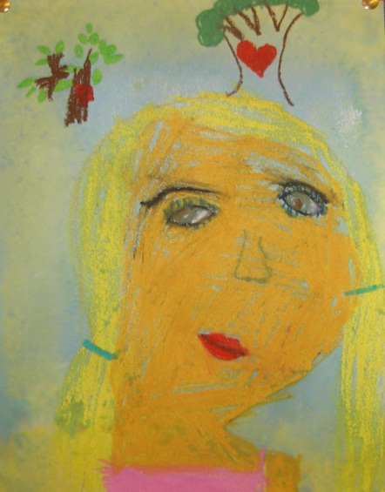
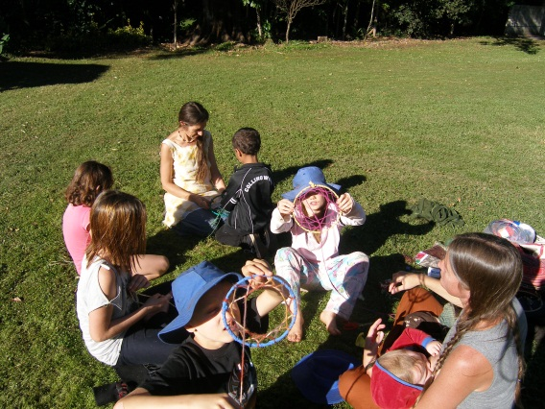
Please join us for a morning of music, art, literacy and laughter.

On Wednesday 1st August,
Wednesday 15th August
and again on Wednesday 22nd August.

Parents will drop children at school between 9-9:30 and collect at 11:00am to attend Pre-school.
Feel free to join us for a “cuppa” and a chat
from 11-11:30.

